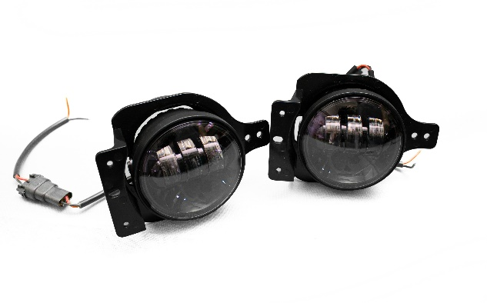
RSJL1804-JEEP JL Blacked Out Series LED Fog Light Kit

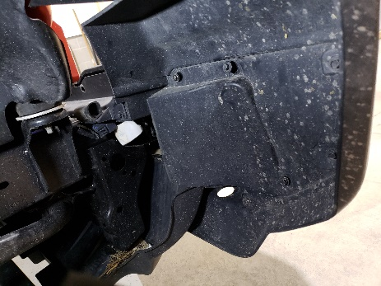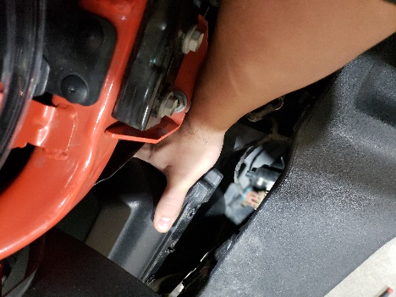
- Begin by removing rear cover from behind the bumper, to get access to fog light assembly.
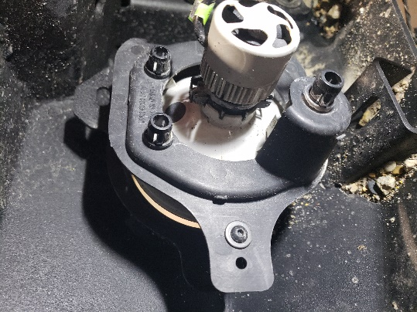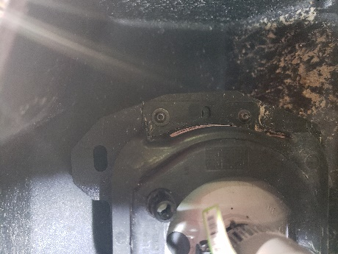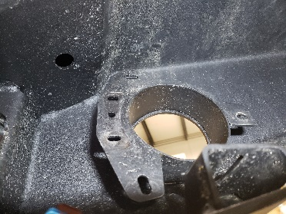
- Once you have access to the fog light assembly you may remove the assembly by removing 3 bolts. They consist of a hex head bolt and a nut on the other side.
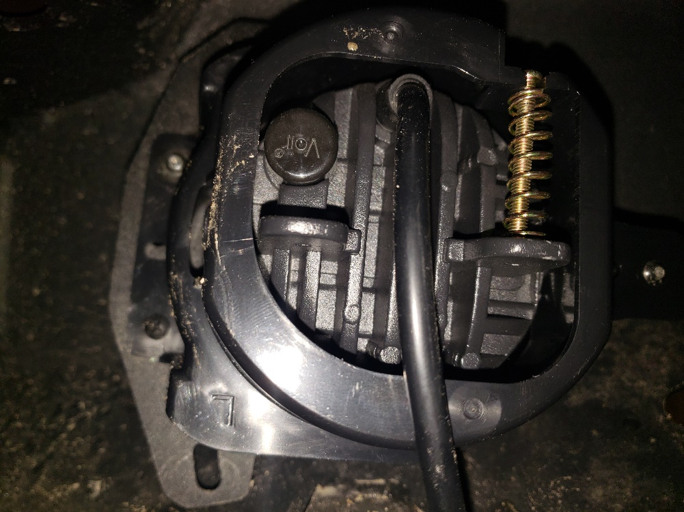
- Once the assembly is off you may replace it with the new assembly and fog light with the factory bolts.
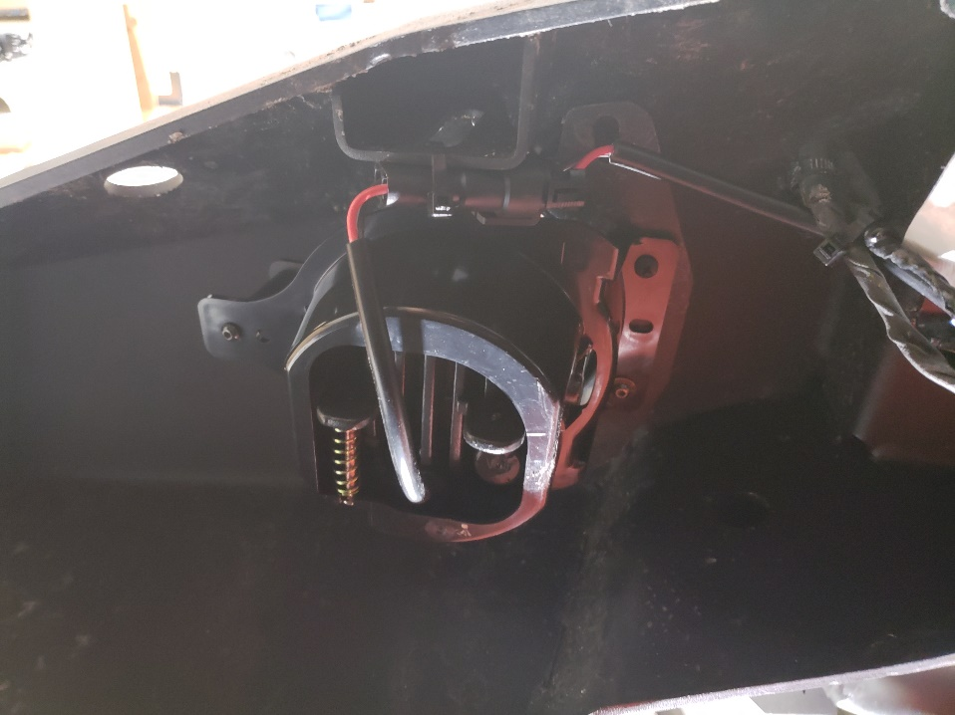
- When the assembly is in its place you may make, your connections. Test polarity with a multimeter solder and shrink wrap you’re connections to the appropriate locations zip tie access wire so that it will not hang and get snagged on anything.
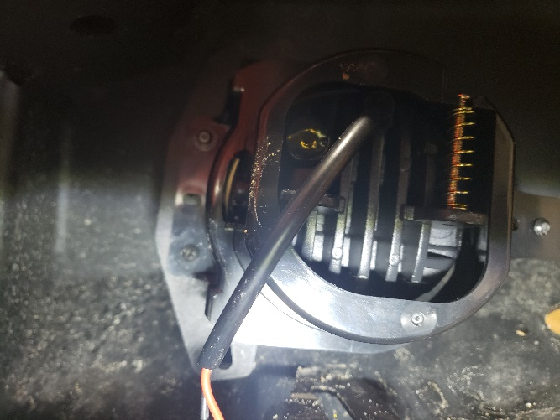
- When connections are made and secured you may adjust light the fog light to preferred height by using the adjuster screw on the back of the assembly and enjoy.

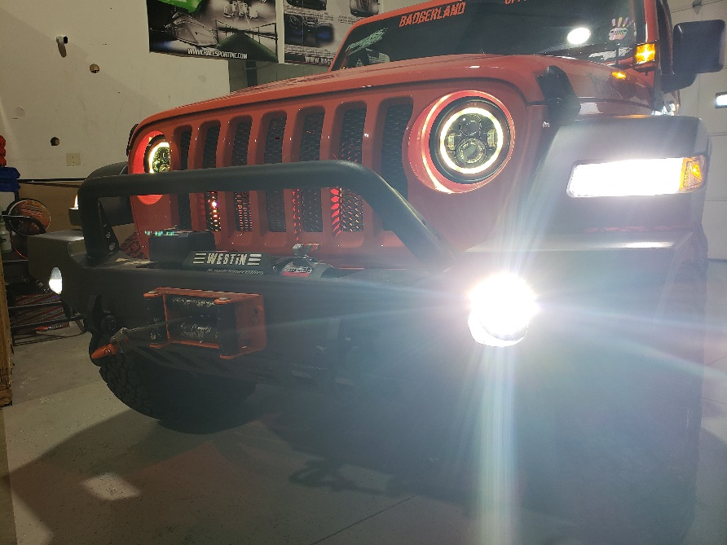
If any questions, please feel free to contact us at tech service @ 847-327-0073 ext. 3

